SOUMITH SRIPATHI
2403A51340
24 SEPETEMBER 2025

ASSIGENMENT 10.2
Task Description-1: AI-Assisted Code Review (Basic Errors)
TASK- Write python program as shown below. Use an AI assistant to review and suggest corrections

PROMPT : "This program calculates the factorial of a given number. It then checks if the calculated factorial is a 'BIG Number' (greater than 10) or a 'small number' and prints the corresponding message."

PROGRAM :
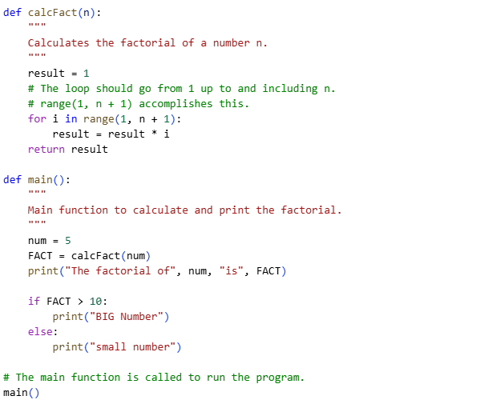
OUTPUT :

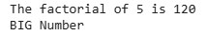

EXPLANATION :
- The original code's range(1, n) is the source of the error. In Python, range(start, stop) generates a sequence of numbers from start up to, but not including, stop.
- To calculate the factorial of n, you need to multiply all numbers from 1 to n.
- The corrected code uses range(1, n + 1), which correctly includes n in the iteration.
- For n = 5, the corrected range(1, 6) will iterate through i values of 1, 2, 3, 4, and 5.
- This results in the correct calculation: 1×2×3×4×5=120.

Task Description-2: Automatic Inline Comments

TASK- Write the Python code for Fibonacci as shown below and execute.
Ask AI to improve variable names, add comments, and apply PEP8 formatting (cleaned up). Students evaluate which suggestions improve readability most. one.

PROMPT : "This program generates and displays the Fibonacci series up to a specified number of elements. The f1 function takes an integer xX and returns a list containing the first xX numbers of the Fibonacci sequence."

PROGRAM :

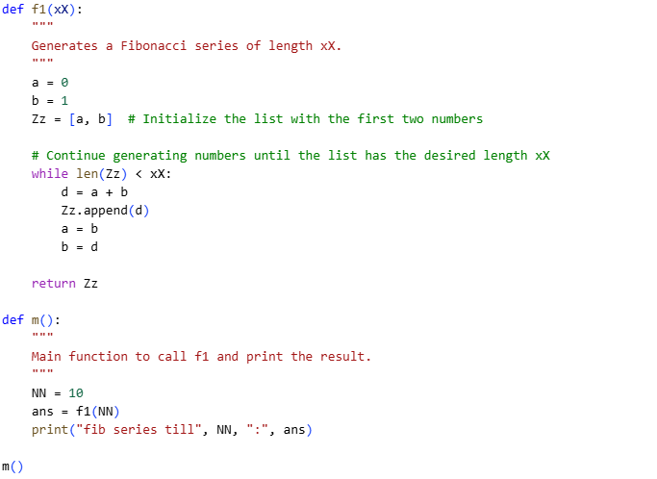

OUTPUT :

EXPLANATION :

- The corrected code replaces the flawed while c <= xX loop with a more intuitive and direct condition: while len(Zz) < xX. This change ensures that the loop continues to generate and append new Fibonacci numbers to the list Zz until the list's length is equal to the input xX. For an input of NN = 10, the loop will run until the list Zz contains exactly 10 elements, producing the correct Fibonacci series of that length.

Task Description-3: Write a Python script with 3–4 functions
(e.g., calculator: add, subtract, multiply, divide). Incorporate manual
docstring in code with NumPy Style

TASK-
- Long Function – A single function tries to do too many things.
- Duplicate Code – Copy-pasted logic in multiple places.
- Poor Naming – Variables or functions with confusing names (x1, foo, data123).
- Unused Variables – Declaring variables but never using them.
- Magic Numbers – Using unexplained constants (3.14159 instead of PI).
- Deep Nesting – Too many if/else levels, making code hard to read.
- Large Class – A single class handling too many responsibilities.

PROMPT :
Write a Python script with 3–4 functions (e.g., calculator: add, subtract, multiply, divide).
Incorporate manual docstring in code with NumPy Style.

PROGRAM :

ADD : 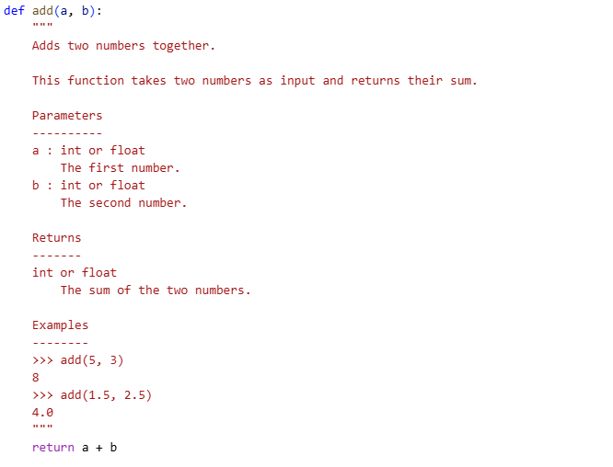

SUBTRACT :

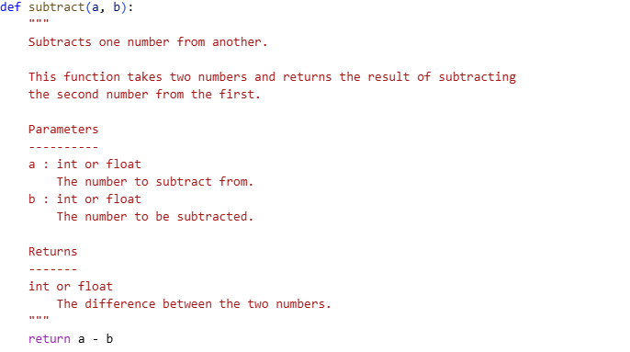

MULTIPLY :

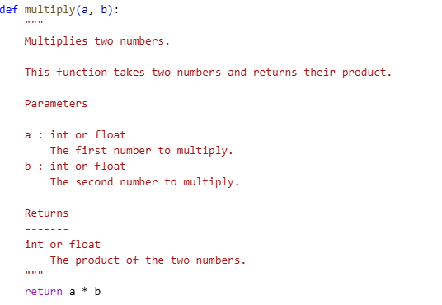

DIVIDE :

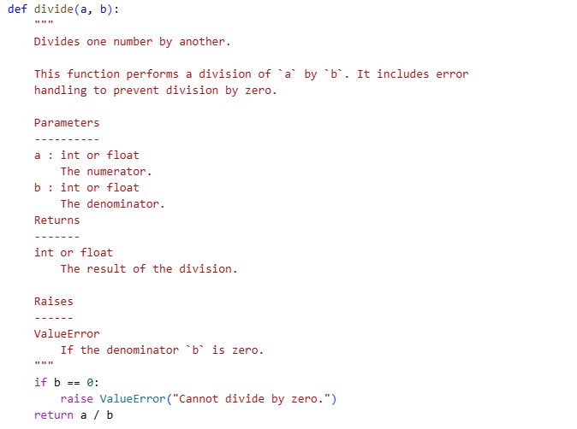

Example usage of the functions

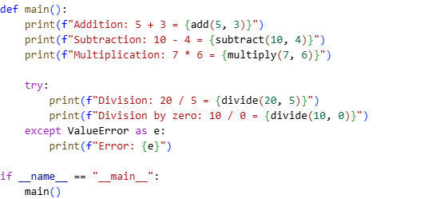

OUTPUT :

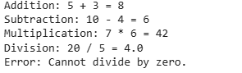

EXPLANATION :

- The manual_docs_calculator.py program is a Python script that contains a simple set of arithmetic functions (add, subtract, multiply, divide). Its primary purpose, as per the prompt, is to demonstrate how to write clear and structured documentation. The code adheres to the NumPy Docstring Style, a widely-used standard for documenting Python code that includes sections for parameters, returns, and examples.
- Each function has a manual docstring that explains its purpose, lists the types and descriptions of its arguments (Parameters), and specifies what it returns (Returns). The divide function also includes a Raises section to document the ValueError exception it throws if a user tries to divide by zero. This structured documentation makes the code easier to understand, use, and maintain, which directly addresses the "code smells" mentioned in your original request.

